Linux tasks

Task- 1 :create a user with name techie and provide sudo access to user .

Created user with name techie and added password techie

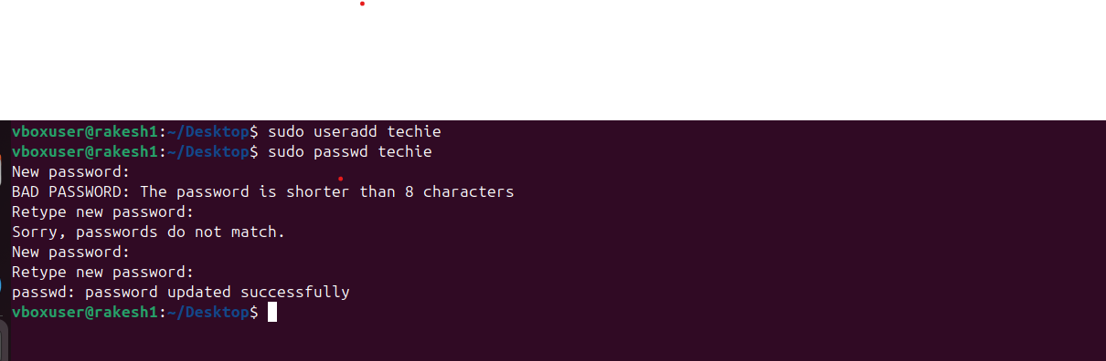

Provide user access to user (techie).visudo
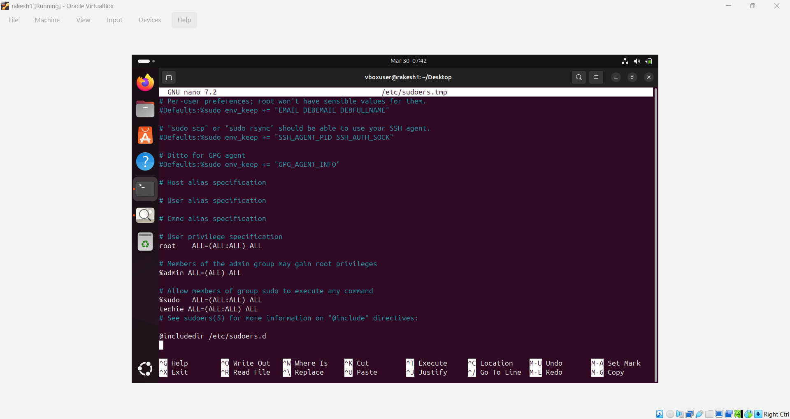

Task 2 – navigate to the home directory
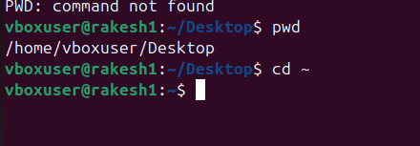

Task -3 : create a new directory
Task -4 : list the contents of the directory
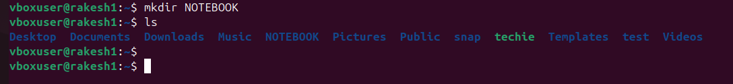

Task -5 : change the current directory
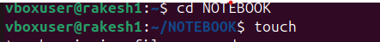
Task -6 : create a new empty file
Task -7 : view the contents of the file

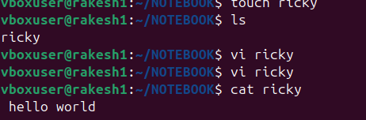

Task -8 : copy a file to another location
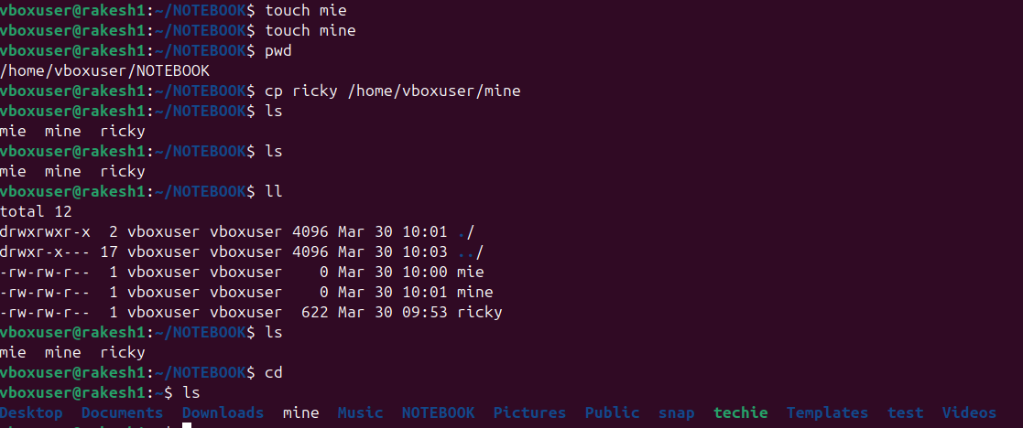

Task – 9 : move a file to another location
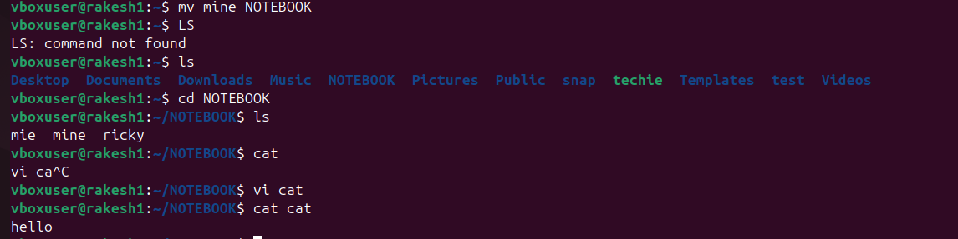

Task -10 : rename a file
Task – 11 : delete a file
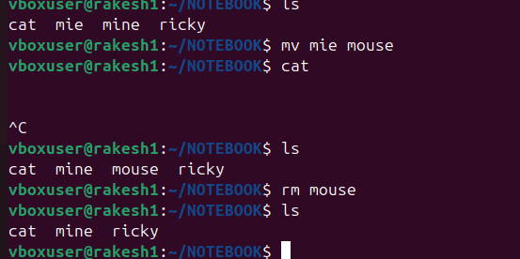

Task – 12 : grant or revoke permissions on a file or directory
Task -13 : view the current date and time
Task – 14 : check the system uptime
Task -15 : view the running process
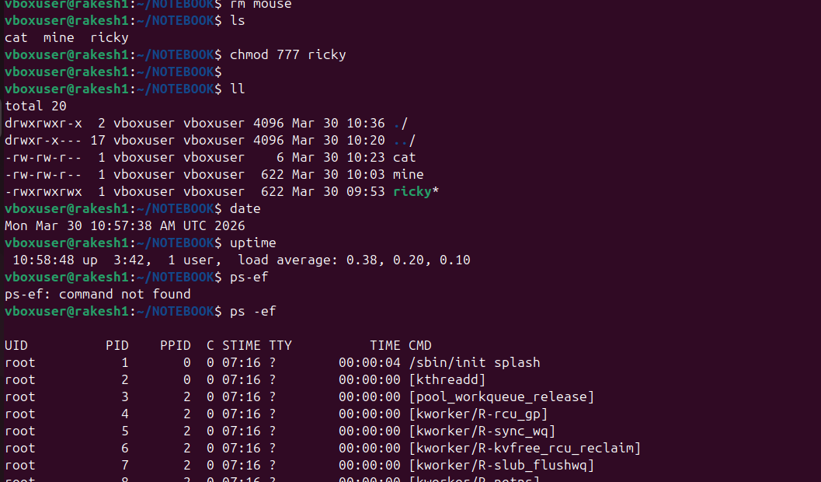
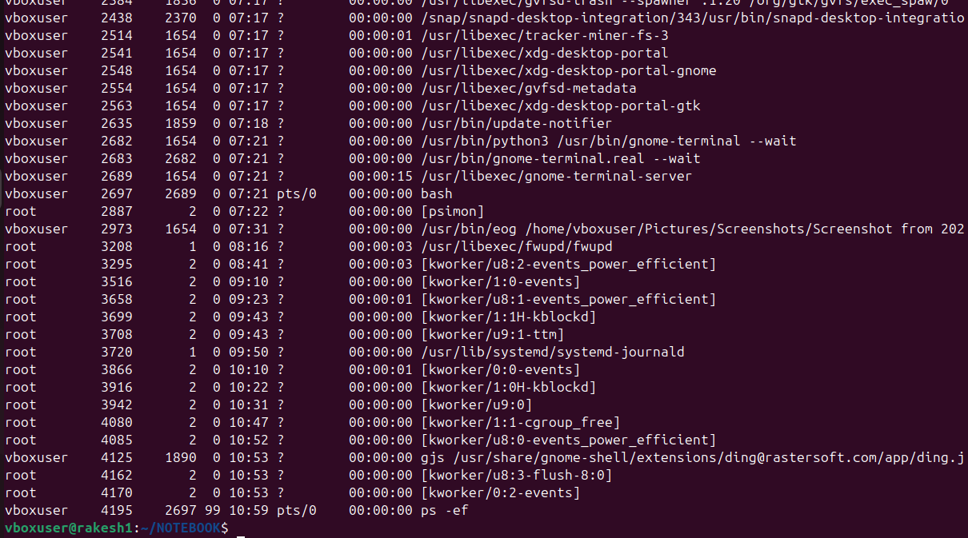

Task -16 : kill a running the process
Task -17 : install a package the using the package manager (eg ; apt or yum)

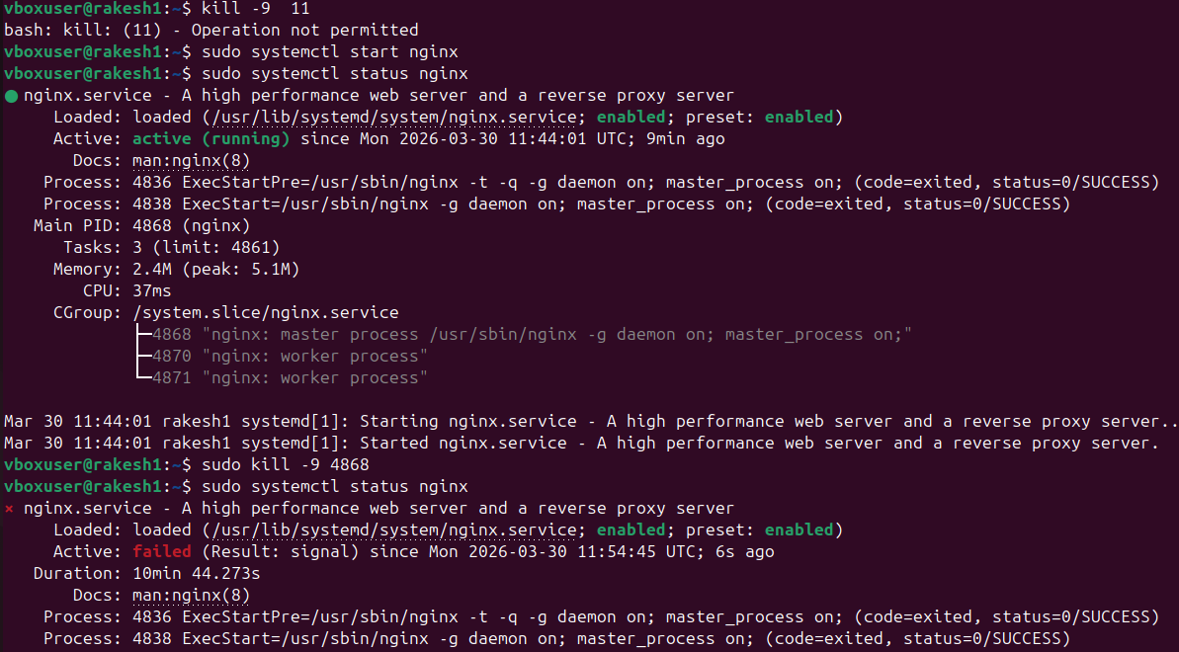
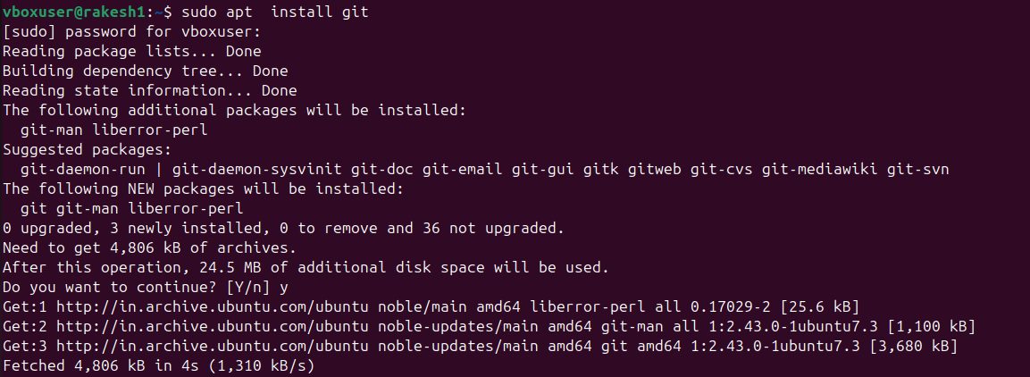

Task – 18 : Update the system packages
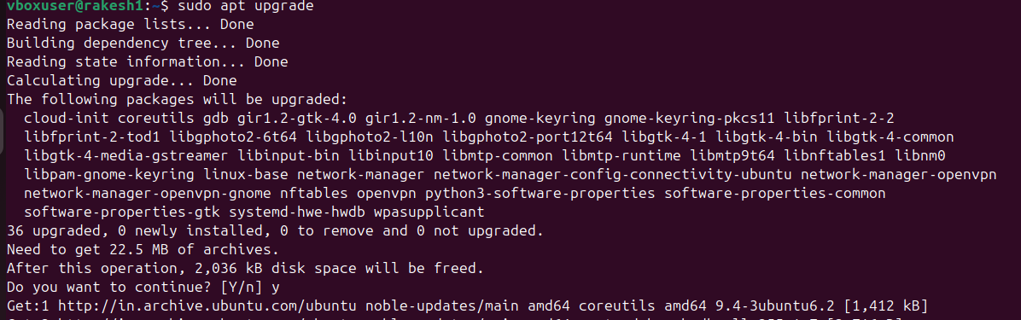
Task -19 : create a symbolic link
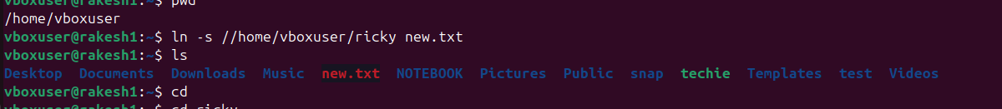
Task – 20 : search for file using the find command

Task – 21 : compress and decompress files using tar

Task -22 : Monitor system resources with top or htop.

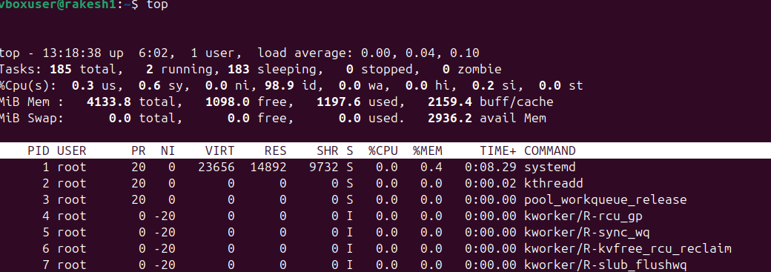
Task -23 : Create and manage user groups.

Task -24 : Set up SSH password less authentication.

Task 25 : Monitor log files using tail or grep.
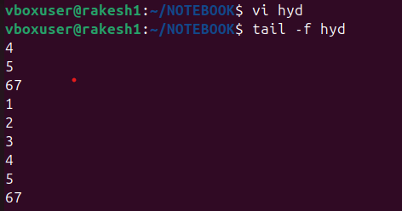

Task -26 : Set up a web server (e.g., Apache or Nginx).
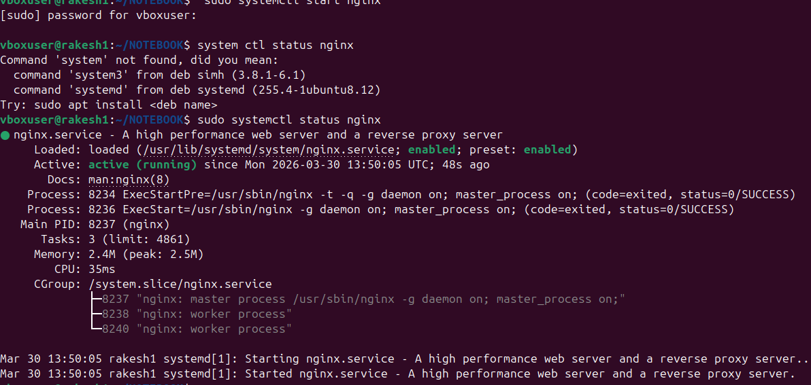

Task -27: Configure and secure a MySQL Database.
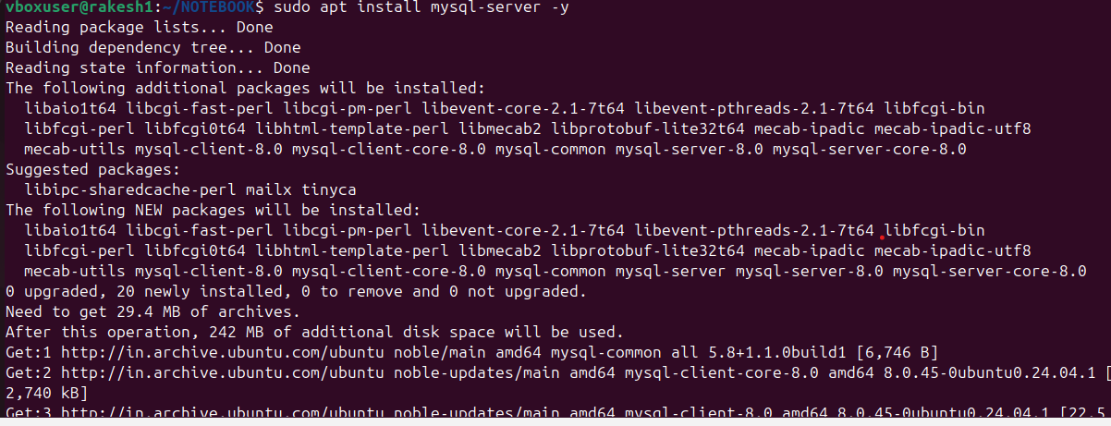
28) Set up a Application Server (e.g.,Apache Tomcat)
29) create a service file for Apache Tomcat.(Should execute by using systemtctl command)
30) Print specific columns from a delimited file.
31) Filter and print lines based on a specific pattern or condition.
32) Calculate and print the average, sum, or other statistics of a column.
33) Perform string manipulation, such as extracting substrings or changing case.
34) Count the occurrences of a specific pattern in a file.
35) Sort lines based on a specific field or column.
36) Merge multiple files based on a common field or column.
37) Substitute text in a file using search and replace.
38) Delete specific lines based on a pattern or line number.
39) Append or insert text before or after a specific pattern or line.
40) Print only specific lines from a file.
41) Copy file from linux to windows machine
42) 5 use cases for AWK and 5 use cases for sed

